Problem Statement & Objectives
Problem Statement:
One of the leading causes of fatalities and property damage, particularly in residences, workplaces and industrial settings is fire. Conventional fire alarm systems frequently use a single sensor and don’t offer remote notifications or real-time monitoring. A smart, dependable IoT enabled fire detection system that can identify fires early and promptly notify users is required.
Objectives:
The main objectives of this project are:
- To design a smart fire alarm system using multiple sensors
- To detect fire using smoke, temperature, humidity and light intensity
- To provide local alerts using buzzer and LED
- To display real-time data on an OLED display
- To enable remote monitoring and control using the Blynk IoT platform

System Architecture / Block Diagram
System Architecture Description:
The system is based on an ESP32 microcontroller which acts as the main controller. Multiple sensors are connected to ESP32 to monitor environmental conditions. When abnormal conditions are detected, te system triggers alarm and send data to the Blynk mobile application via WiFi.
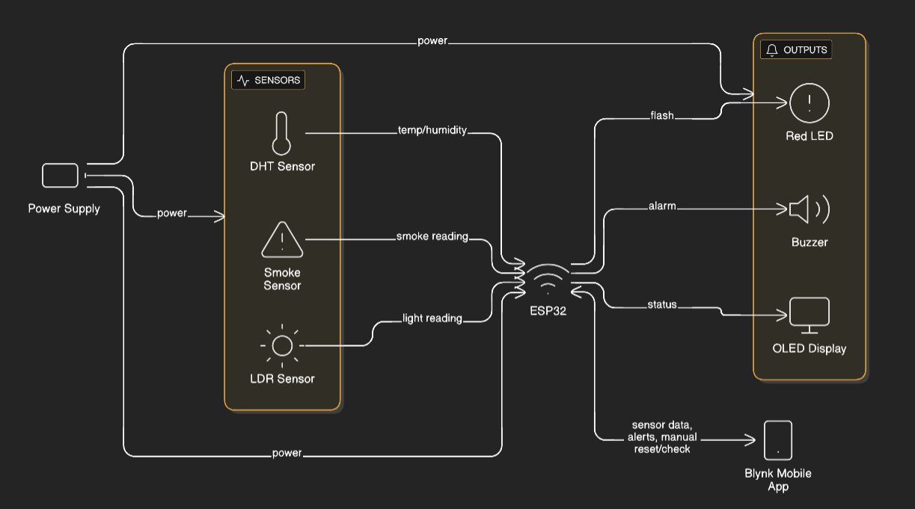

Hardware and Software Description
Hardware Components:
Component | Description
ESP32 | Main Controller with built-in WiFi
Smoke Sensor | Detects Smoke presence
DHT11 | Measures temperature and humidity
LDR | Detects sudden increase in light
OLED Display | Displays System status
Buzzer | Audible fire alarm
Red LED | Visual fire detection
Push Button | Manual reset
Power Supply | Provides power to the system

Software Components:
- VS Code IDE – For programming ESP32
- Blynk IoT Platform – Mobile monitoring and control
- Libraries used:
  - WiFi.h
  - BlynkSimpleEsp32.h
  - Adafruit_SSD1306.h
  - Adafruit_GFX.h
  - DHT.h

Methodology and Flowchart
Methodology:
- ESP32 initializes all sensors OLED, WiFi and Blynk connection.
- Sensors continuously monitor smoke, temperature, humidity and light.
- If smoke or light exceeds threshold:
- Temperature and humidity are checked
4. If fire conditions are confirmed:
- Buzzer and LED are activated
- Warning message displayed on OLED
- Alert Sent to Blynk app
5. System automatically resets after a fixed time or manually via Blynk.

Flowchart:

Screenshots of output and dashboard
Results, Conclusion and Future scope
Results:
- The system successfully detects fire conditions using multiple sensors.
- Local alarms activate immediately.
- Real-time data is displayed on OLED and Blynk app.
- Remote monitoring and manual reset work effectively.
Conclusion:
The IoT based fire alarm system provides a reliable, efficient and smart solution for early fire detection. By integrating multiple sensors with IoT technology, the system improves accuracy and response time. This project demonstrates the practical application of embedded systems and IoT in safety-critical environments.
Future scope:
- Integration with SMS or email alerts
- Adding sprinkler system
- Cloud-based data logging and analytics
- Integration with smart home systems

